1. - Top 5 breeds that are most frequently adopted for each shelter.

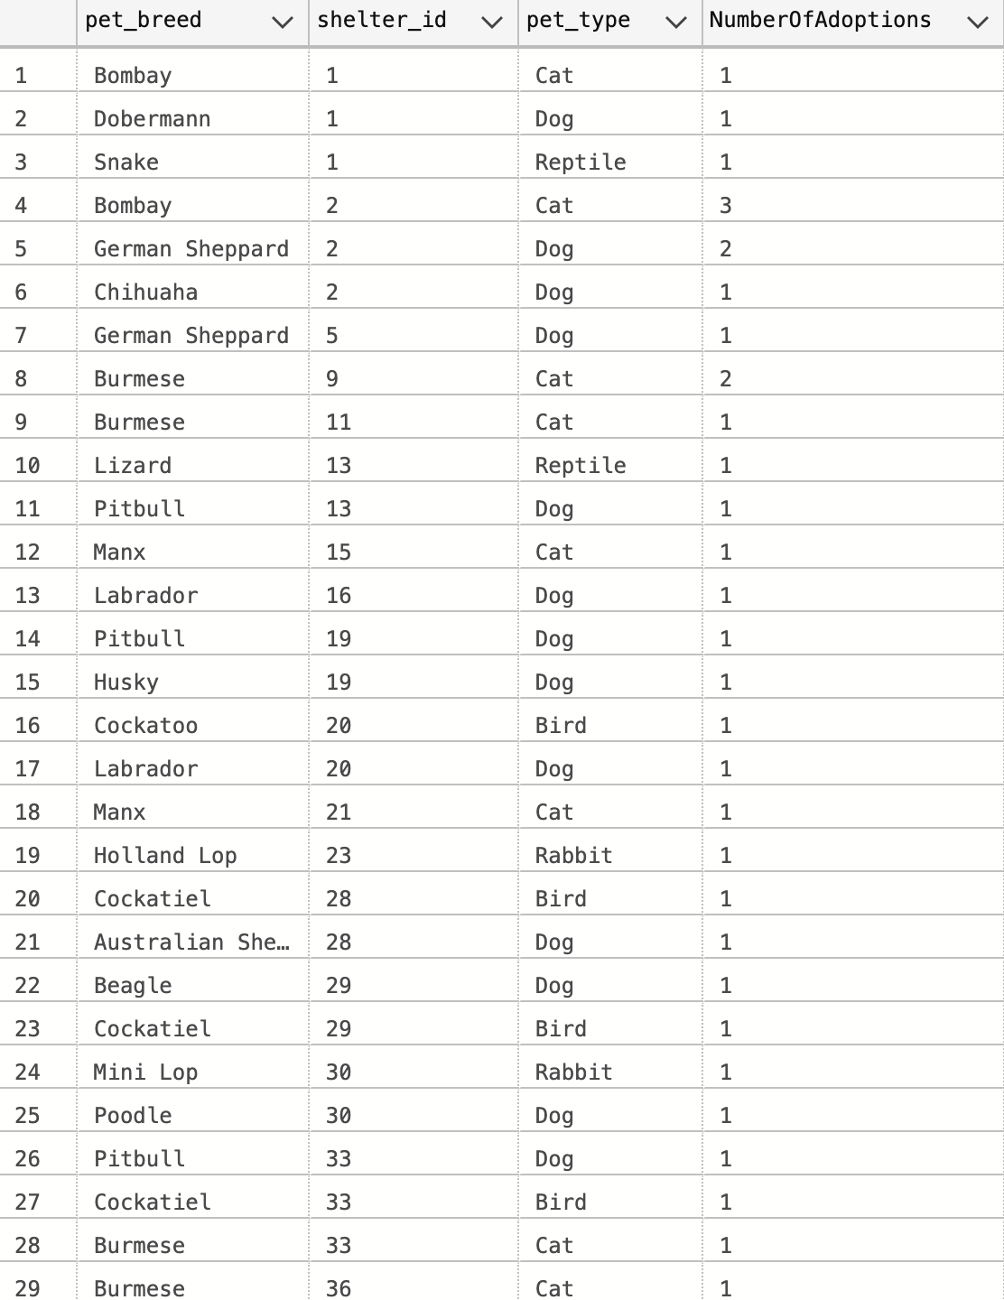

- Summary: This query shows the top 3 pet breeds and type of pet for each shelter that has been adopted. The report stands out that Cats are mostly popular, specifically the Burmese cat. This indicates that there is a popularity with this specific breed of cat. However, its adoption popularity and rate may prove detrimental to other cat breeds being adopted.

2. - Adopters who are single and have more than 1 kid who has adopted a pet.

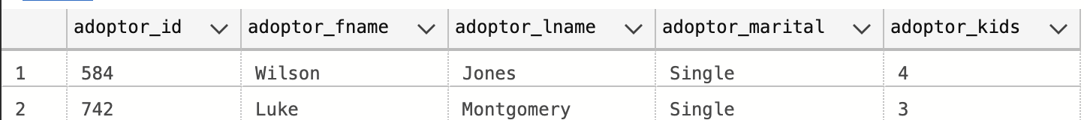

- Summary: In this query, we wanted to see if there is any indication that single parents with more than one kid have adopted a child. It seems as though only two adoptors fit the specification. This could either mean that most single adopters with multiple children cannot handle a pet without co-parenting. If looked further, we could see if Single parents have been approved but as it looks, most do not want a pet in their home.

3. - List all employees who provide special healthcare for pets and their contact information.

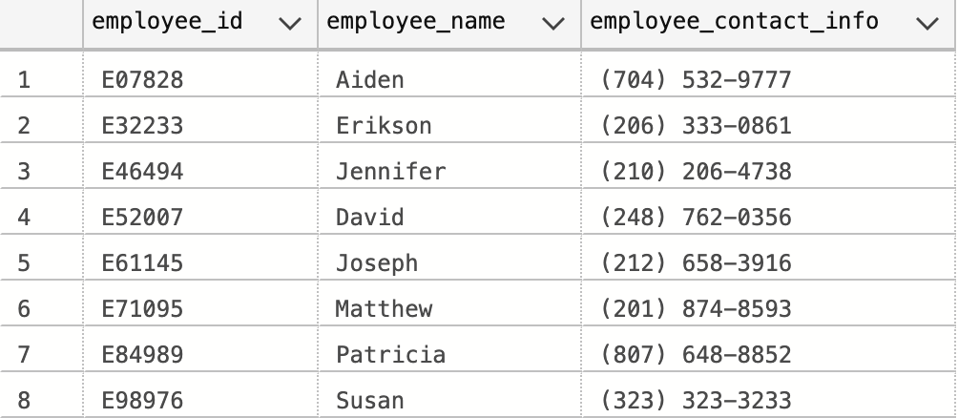

- Summary: In this report, we look at all the employees who can provide special healthcare. Only 8 employees can provide special healthcare services to pets. The amount is very little considering there are more pets in the shelter.

4. - Employees that take care of medium-sized dogs.

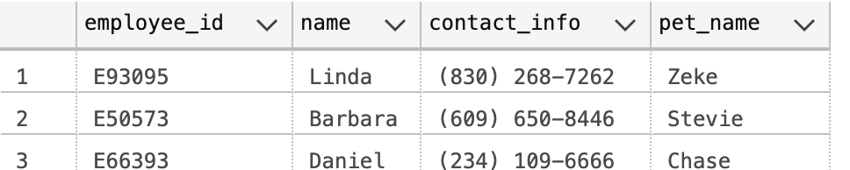

- Summary: This report shows employees that take care of medium size dogs. There are only 3 when there are more employees than this. This indicates that the shelters have an unequal distribution of pet care tasks to different-sized dogs, moreso that fewer employees take care of medium-sized dogs. To solve this problem, shelters must reassign pet care tasks to take care of an equal amount of all dog sizes.

5. - Cities that have an average age of adopters over 30 years old.

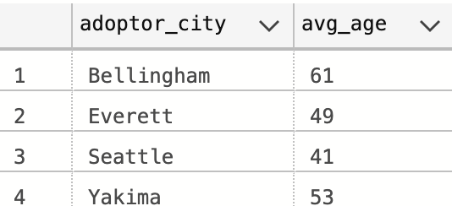

- Summary: The report shows all cities with an average age for adopters above 30 years of age. This data can help us relocate pets to nearby shelters as older people tend to adopt pets on the older side. It will not only help pets who are older to be adopted more frequently, it will also help older/seniors to travel less distance to adopt a pet making the adoption process much easier for them.

6. - Adopters who have adopted a pet from the shelter with the highest number of adoptions.

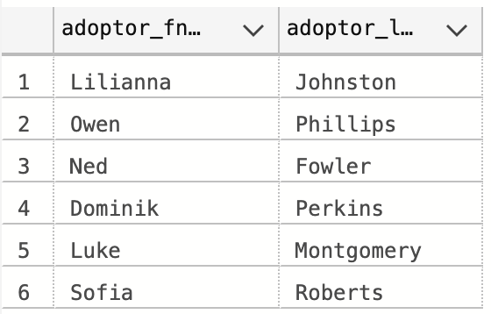

- Summary: In this report, we are looking for adopter’s name who adopted a pet with the highest number of adoptions. As we can see, 6 adopters adopted a pet from the shelter that has the highest number of adoptions. This data helps us to see some insights into the shelter that has the highest number of adoptions.

7. - Calculate the number of adoptions per pet breed, then list the pet breed with more adoptions than the average.

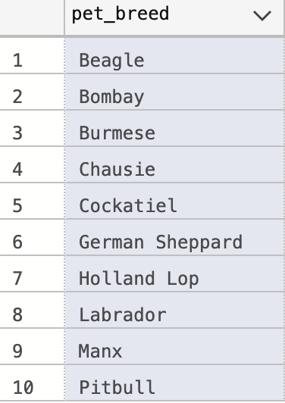

- Summary: This report gives us a list of popular pet breeds that have been adopted more than the average adoption rate. It gives us an insight into some popular pet breeds that adopters willing to adopt and also provides the average adoption rate of the pet breed.

8. Top 5 months with the highest number of pet adoptions over the past year, list the pet type that was adopted the most during each of these months. Also provides the count of adoptions for that pet type.

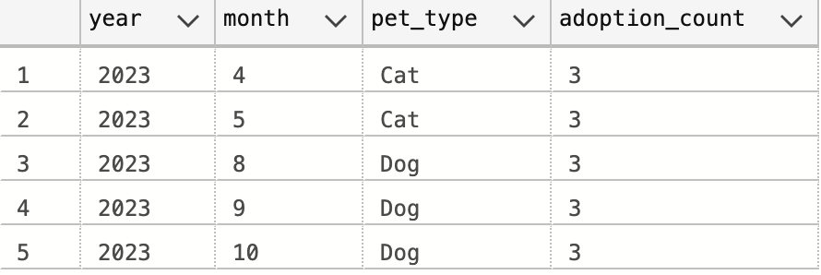

- Summary: This report listed the top 5 of the most pet-adopted months over the past year. It provides insight into the top 5 months and also the pet type information with the number of adoptions made in that month. With this information, we can see which type of pet is more popular, and which month has more people willing to adopt a pet.

9. - Determine the shelter that has provided the most pets for adoption and list the details of all pets from this shelter.

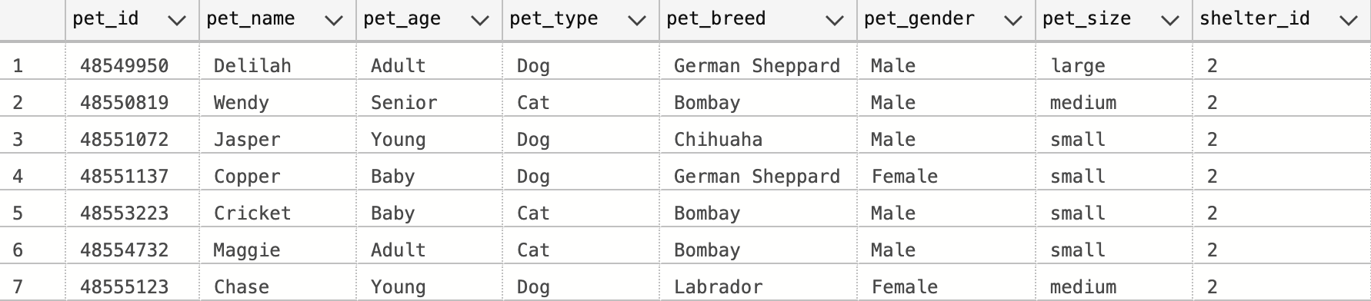

- Summary: This report lists the details of pet information of the shelter that provided the most pet adoptions. It gives us insight into the shelter that has the most pet adoptions and also what types of pets and breeds are in the shelter.

10. - List all adopters who live in Seattle have an above-average salary who are married and adopted a cat that has special healthcare.



- Summary: We are searching for Seattle residents who have adopted a cat with special healthcare needs, are married, and have above-average incomes. By cross-referencing data from various databases, we can obtain information that will help us create targeted marketing strategies and customized adoption events for this specific audience. This information can also be used to support married adopters in Seattle who have cats with special healthcare needs.

11. - Identify donors who made multiple donations.

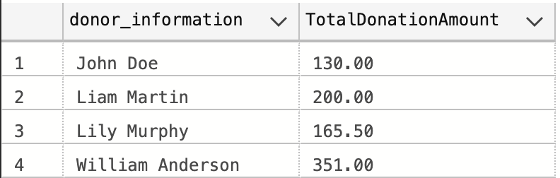

- Summary: This query aims to identify donors who have made multiple donations by aggregating data from the "Donation" table. The results include donor information and the total donation amount contributed by individuals who have made more than one donation. This information provides insights into the engagement and commitment levels of donors, allowing for tailored appreciation efforts, personalized acknowledgment, or exclusive engagement programs for frequent contributors.

12. - Find the total number of animals in each shelter—order by descending.

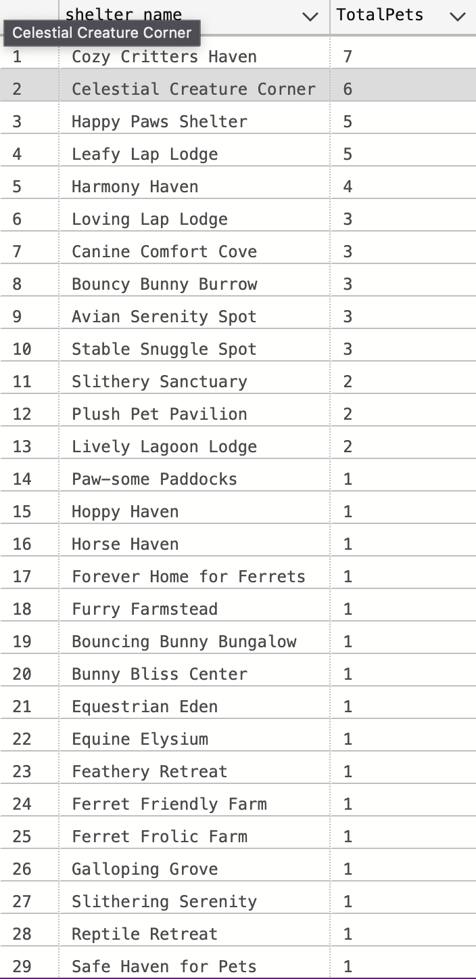

- Summary: This query helps to find the number of animals in each shelter, sorted by the count of pets in descending order. By joining data from the "Shelter" and "Pets" tables, the query determines the total number of animals in each shelter. This information is crucial for shelter management to allocate resources efficiently and make strategic decisions.

13. - Find employees who conducted interviews for eligible adopters.

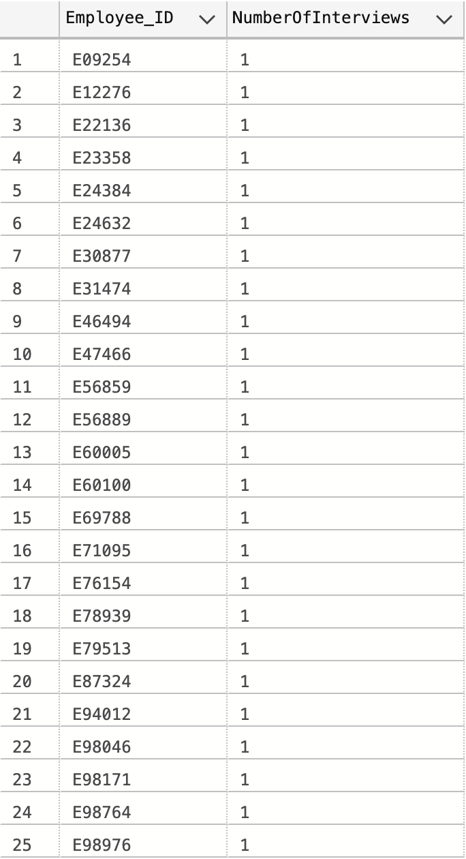

- Summary: This query identifies employees who conducted interviews for eligible adopters. The query uses the "Employee" and "Interview" tables, filtering results based on interviews where adopters are eligible. The COUNT() function calculates the number of interviews conducted by each employee. This information is useful for assessing employee engagement in the adoption process and identifying staff members who actively facilitate adoptions for eligible adopters.

14. - Money donation trend in the last three months.

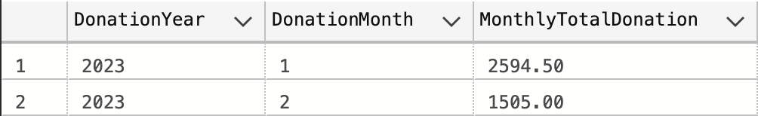

- Summary: The query aims to analyze the trend of money donations over the past three months. It uses a Common Table Expression (CTE) named "MonthlyDonationTrends" to aggregate and summarize donation data each month. The SELECT statement retrieves the DonationYear, DonationMonth, and MonthlyTotalDonation columns from the CTE. This information helps identify peak donation months and periods of lower contributions, enabling the organization to adjust fundraising strategies and allocate resources accordingly.

15. - Identify what age is being adopted the most from each shelter when age is baby, young, adult, or senior.

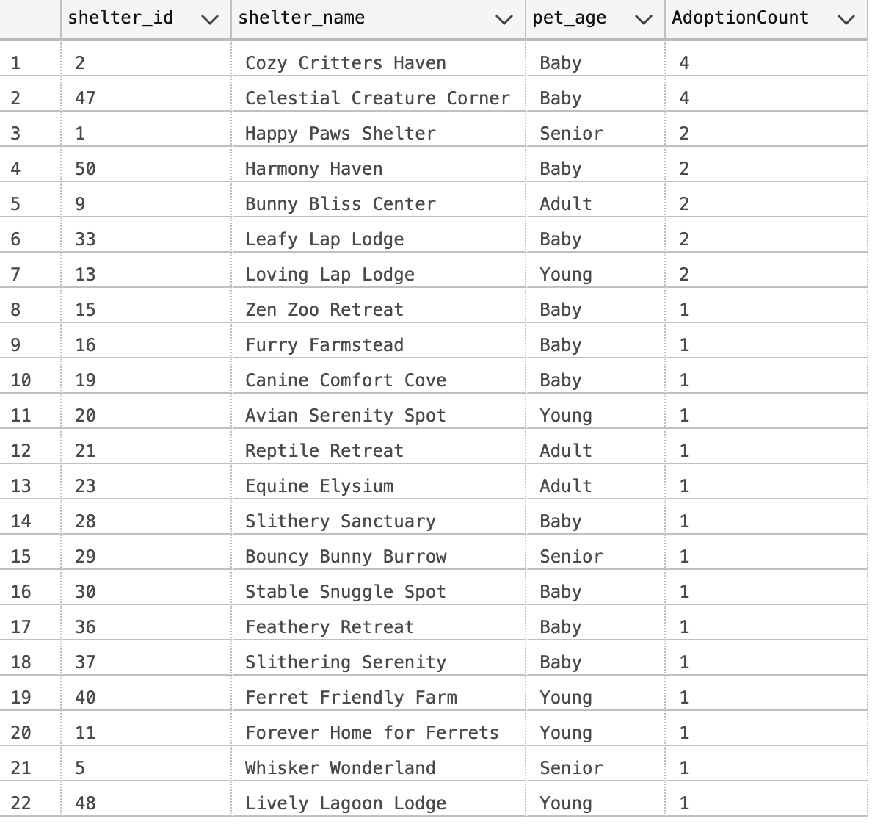

- Summary: This query identifies the most adopted age group of pets from each shelter. Two Common Table Expressions calculate the adoption count and assign a rank to each age group within each shelter. The SELECT statement retrieves the shelter ID, name, pet age, and adoption count for the age group with the highest adoption count from each shelter. This information helps shelters understand the preferences of adopters and allocate resources accordingly.

16. Donors with Increasing Donation Amounts.

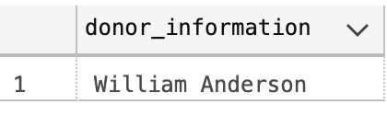

- Summary: This query identifies donors who have increased their donations over time using a Common Table Expression (CTE) called "DonorDonationHistory". It retrieves distinct donor information for donors whose current donation amount is greater than their previous donation amount. The query provides valuable insights into donor behavior, which helps organizations recognize and show appreciation.

17. - List Adopters Eligible for Interview and Their Preferred Shelter.

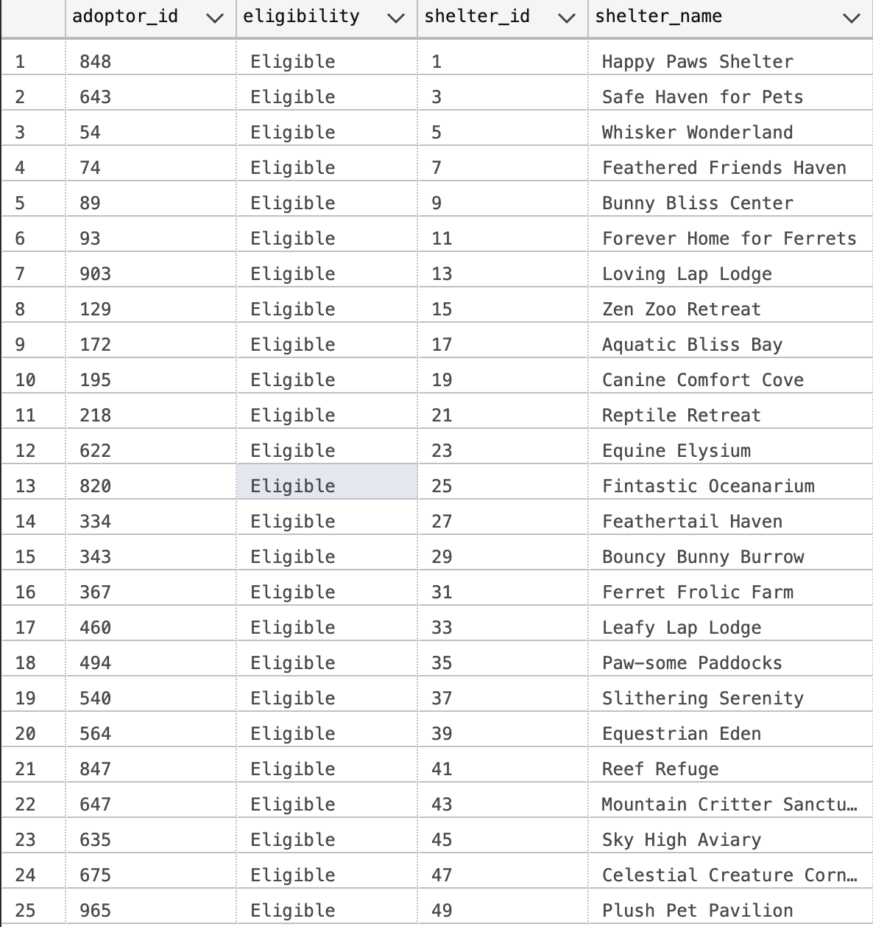

- Summary: This query is to create a list of eligible adopters and their preferred shelter for an interview, use a SELECT statement to retrieve adopter_id, eligibility status, shelter_id, and shelter_name from the Interview, Employee, and Shelter tables by joining them based on the relevant foreign key relationships. Filter the results with a WHERE clause to include only eligible adopters. Use the query results to showcase the adopters' eligibility status and preferred shelters in the project report to emphasize the importance of personalized adoption processes, leading to increased adoption rates. tes and overall satisfaction for both adopters and shelters.

18. Top pet types.

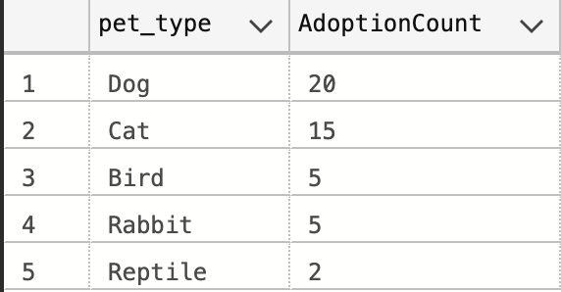

- Summary: The purpose of this query is to determine the top pet types based on adoption counts. It does so by calculating the adoption count for each pet type and then retrieving and ordering the results by pet_type in descending order based on the AdoptionCount.